|  |  |
| --- | --- |
| **Module:** | ST2053 |
| **Name:** | Maxim Chopivskyy |
| **Student Number:** | 118364841 |
| **Chapter:** | 4 |

**Maximum 2 pages! Do not delete the page number in the footer.**

(a)

**Q4.1.lm:**

injection.df = read.table("P:\\ST2053\\Previous Exam Datasets\\18-19\\Injection.txt", header = TRUE)

attach(injection.df)

par(mfrow=c(2,2))

injection.df

scatter.smooth(Time, Conc, main="Scatter.smooth plot")

injection1.lm = lm(Conc ~ Time, data=injection.df)

plot(fitted(injection1.lm), resid(injection1.lm), main="Plot of Residual V Fitted Values")

abline(h=0, lty=2)

hist(resid(injection1.lm), main="Histogram of Residuals")

qqnorm(resid(injection1.lm), main="Normal Probability Plot of Residuals")

qqline(resid(injection1.lm))

par(mfrow=c(1,1))

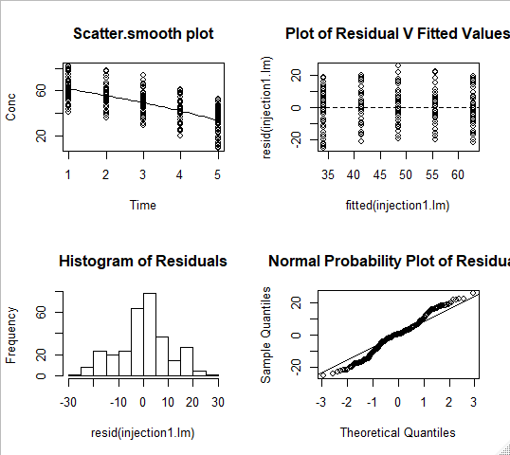

Scatter-plot: linear & constant variance

Residuals vs fitted values: linear & constant variance

Histogram: approximately normal

Normal probability plot: non-normal

**Q4.2.lm:**

par(mfrow=c(2,2))

scatter.smooth(sqrt(Time), Conc, main="Scatter.smooth plot")

injection2.lm = lm(Conc ~ sqrt(Time), data=injection.df)

plot(fitted(injection2.lm), resid(injection2.lm), main="Plot of Residual V Fitted Values")

abline(h=0, lty=2)

hist(resid(injection2.lm), main="Histogram of Residuals")

qqnorm(resid(injection2.lm), main="Normal Probability Plot of Residuals")

qqline(resid(injection2.lm))

par(mfrow=c(1,1))

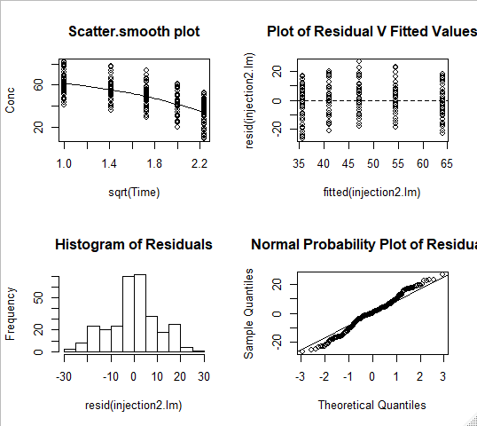

Scatter-plot: non-linear & constant variance

Residuals vs fitted values: non-linear & constant variance

Histogram: approximately normal

Normal probability plot: non-normal

**Q4.3.lm:**

par(mfrow = c(2,2))

scatter.smooth(log(Time), Conc, main="Scatter.smooth plot")

injection3.lm = lm(Conc ~ log(Time), data=injection.df)

plot(fitted(injection3.lm), resid(injection3.lm), main="Plot of Residual V Fitted Values")

abline(h=0, lty=2)

hist(resid(injection3.lm), main="Histogram of Residuals")

qqnorm(resid(injection3.lm), main="Normal Probability Plot of Residuals")

qqline(resid(injection3.lm))

par(mfrow=c(1,1))

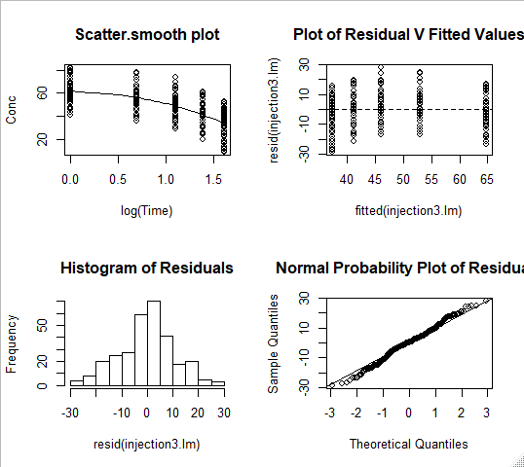

Scatter-plot: non-linear & constant variance

Residuals vs fitted values: non-linear & constant variance

Histogram: non-normal

Normal probability plot: approximately normal

(b)

I would choose model 1 for these data.

The Scatter-plot is linear and has constant variance for model 1. The residuals vs fitted values plot is linear and has constant variance. The histogram is approximately normal. The qqplot is almost normal.

Model 1 comes closest to meeting assumptions.

(c)

Model 1, our best model, doesn’t meet all assumptions. The qqplot is non-normal.

I would recommend making other models with other combinations of transformations to improve assumptions.